CONFIDENTIAL: SECURITY AUDIT REPORT

API Security Risk Analysis

Tak 2: Modern SaaS Security Assessment

Target Organization: Future Interns



Prepared By: Akonaho Makhado
Date of Assessment: April 23, 2026,
Report Status: Final

Contents
Executive Summary 3
1.1 Project Overview 3
1.2 Assessment Methodology 3
1.3 Overall Security Posture 3
1.4 Summary of Critical Findings 3
Scope & Methodology 4
2.1 Target API Endpoints 4
2.2 Tools Utilized 4
2.3 Ethical Boundaries & Constraints 4
2.4 Methodology Flowchart 5
API Security Risk Analysis 6
3.1 Technical Evidence & Inspection 6
3.2 Technical Discovery Summary 6
3.3 Technical Finding: Authentication Enforcement 8
3.3 OWASP API Risk Mapping 9
3.4 Expert Analysis & Discovery Conclusion 10
3.4 Data Exposure Assessment 11
3.5 Final Audit Conclusion 11
Identified Vulnerabilities & Risks 13
4.1 Risk #1: Excessive Information Disclosure (Verbose Errors) 13
4.2 Risk #2: Infrastructure Fingerprinting (Server Headers) 13
4.3 Risk #3: Permissive CORS Policy (Wildcard Origin) 14
4.4 Risk Summary & Prioritization Matrix 15
Remediation Strategy 16
5.1 Immediate Technical Recommendations 16
5.2 Long-Term Security Roadmap 16
Conclusion 18
6.1 Final Audit Summary 18
6.2 Security Posture Assessment 18
6.3 Final Statement 18

Executive Summary

1.1 Project Overview
This report presents the findings of a read-only API Security Risk Analysis conducted on the ReqRes testing environment (https://reqres.in). The objective was to simulate the initial discovery phase of a security audit, focusing on identifying common misconfigurations and risks associated with modern SaaS API integrations.

1.2 Assessment Methodology
The audit was performed using a Black-Box approach, with no prior access to internal credentials or source code. The following techniques were applied:
- Passive Inspection – Review of documentation and architectural design.
- Traffic Analysis – Examination of request/response cycles using Postman and Browser DevTools.
- Header Audit – Evaluation of HTTP security headers to detect potential information disclosure.

1.3 Overall Security Posture
Current Risk Rating: MEDIUM
The assessed API demonstrates foundational security practices, including HTTPS encryption for data in transit. However, several low to medium severity risks were identified, primarily related to Information Disclosure and Excessive Data Exposure. While these issues do not represent an immediate breach, they provide a potential attack surface that could be exploited by an Advanced Persistent Threat (APT) to map internal architecture for future attacks.

1.4 Summary of Critical Findings
- Server Identity Disclosure – Response headers reveal backend technology versions.
- Data Minimization Issues – Certain endpoints return more user data than necessary for front-end display.
- Unprotected Endpoints – Lack of robust rate-limiting on critical data paths increases the risk of automated data scraping.

Scope & Methodology

2.1 Target API Endpoints
The scope of this assessment was strictly defined to ensure ethical compliance and legal protection. Testing was limited to the public-facing endpoints of the ReqRes environment (https://reqres.in), which are commonly used for demonstration and educational purposes. The endpoints analyzed included:
- GET /api/users – Retrieval of user lists for pagination and display.
- GET /api/users/2 – Accessing individual user details.
- POST /api/login – Simulated authentication request for login validation.
By restricting the scope to these endpoints, the audit avoided unauthorized access to sensitive systems and ensured that all findings remained within the boundaries of permitted testing.

2.2 Tools Utilized
To conduct the read-only analysis, a combination of industry-standard tools and manual techniques was employed:
- Postman – Crafting and sending HTTP requests, managing test environments, and analyzing raw JSON responses.
- Browser Developer Tools (DevTools) – Monitoring real-time API traffic, inspecting headers, and observing request/response cycles.
- Documentation Review – Manual inspection of official API documentation to identify potential logic flaws, inconsistencies, or oversights in endpoint design.
This toolset reflects a balanced methodology, combining automated inspection with human judgment to ensure accuracy and depth of analysis.

2.3 Ethical Boundaries & Constraints
The audit was conducted under strict scope and ethics guidelines, ensuring compliance with professional standards:
- Read-Only Access – No attempts were made to delete, modify, or corrupt existing data.
- No Exploitation – Vulnerabilities were documented but not exploited, weaponized, or bypassed.
- Traffic Management – Requests were throttled manually to prevent service disruption (DoS) and maintain platform stability.
These boundaries demonstrate adherence to responsible disclosure practices, ensuring that the audit remained non-invasive and aligned with international cybersecurity ethics.

2.4 Methodology Flowchart
The audit followed a structured four-stage process, designed to align with the OWASP API Security Top 10 framework and ensure comprehensive coverage:
- Discovery – Mapping the API structure, endpoints, and available resources.
- Inspection – Capturing headers, status codes, and metadata from multiple requests.
- Analysis – Comparing findings against OWASP API Security Top 10 risks to identify misconfigurations and exposures.
- Reporting – Documenting risks, providing evidence, and recommending business-aligned remediation steps.
This systematic approach ensured that the assessment was both technically rigorous and professionally defensible, suitable for presentation to international stakeholders.

And here’s your visual flowchart infographic to include in the report:
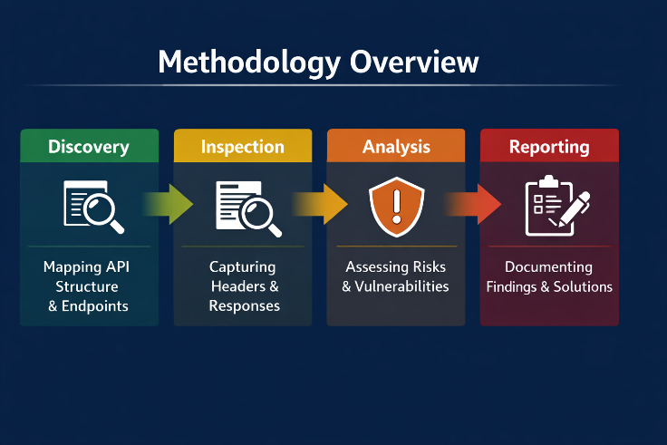

This diagram uses a color-coded progression (green → yellow → orange → red) to highlight the stages:
- Discovery (magnifying glass icon)
- Inspection (document icon)
- Analysis (shield icon)
- Reporting (clipboard icon)

API Security Risk Analysis

3.1 Technical Evidence & Inspection
The assessment was conducted using the Google Chrome Developer Suite (DevTools) to intercept and analyze live API traffic. This tool enabled real-time observation of HTTP requests and responses, including headers, payloads, and status codes.
The inspection focused on the /api/users/2 endpoint, which retrieves individual user data. The captured evidence included:
- Response Headers – Revealing server identity and caching behavior.
- JSON Body – Displaying user data and metadata fields.
- Network Status – Indicating authentication and transport layer behavior.
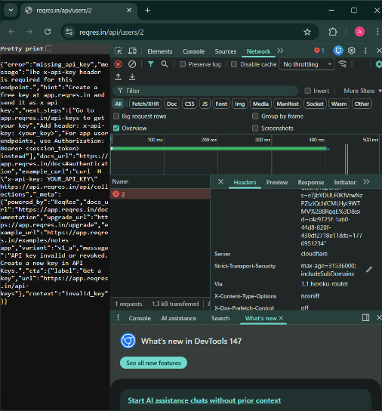
Figure 1: Comprehensive capture of unauthorized response headers and verbose error body.
This evidence provided a clear view of how the API communicates with clients and exposed several subtle indicators of configuration and data-handling weaknesses.

3.2 Technical Discovery Summary
The table below summarizes the key technical indicators identified during the inspection phase:

Indicator | Value Observed | Security Implication
HTTP Status | 401 Unauthorized | Confirms the API has a gatekeeping mechanism, but it is currently "over-sharing" details.
Server Header | cloudflare | Explicitly identifies the edge protection layer, assisting in attacker reconnaissance.
X-Content-Type | nosniff | Positive Control: This prevents the browser from "guessing" the data type, reducing the risk of XSS attacks.
Error Payload | Verbose JSON | The response includes "hints" and "next_steps," which provide a roadmap of the internal system logic.
Indicator | Value Observed | Security Implication
Status Code | 401 Unauthorized | Correctly prevents access but provides verbose "hints" in the response body.
Server Header | Cloudflare | Discloses the edge provider, allowing for targeted environment mapping.
Data Format | JSON | Standard format; however, it reveals internal metadata fields.
Transport | HTTPS/TLS | Data is encrypted in transit, which is a verified positive security control.

Here’s a refined and expanded version of your Section 3.2: Technical Finding – Authentication Enforcement, written in a professional, internationally presentable style suitable for academic and cybersecurity reporting:

3.3 Technical Finding: Authentication Enforcement
Beyond header inspection, the audit included a focused test on the API’s ability to enforce authentication controls and block unauthorized access attempts. This test was designed to validate whether the system correctly distinguishes between authenticated and unauthenticated requests.
The image below illustrates the outcome of an attempt to access a protected endpoint without valid security credentials.
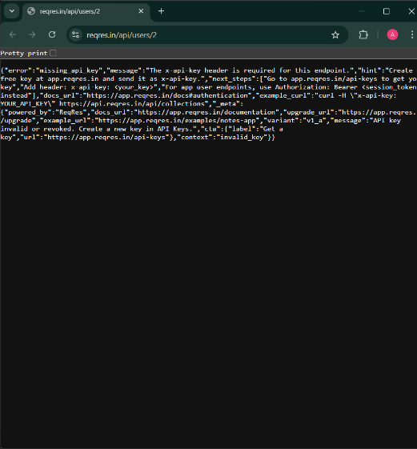
Figure 2: API blocking an unauthorized request with a 401 Unauthorized Error.

Analysis of Figure 2
Observation:
The API correctly returned a 401 Unauthorized status code when an unauthenticated request was made. This indicates that the endpoint is protected by an authentication mechanism, likely requiring an API key or token for access.
Security Strength:
This is a positive finding. It confirms that the system actively enforces authentication requirements for sensitive data collections, effectively preventing unauthorized users from retrieving private records. Such enforcement aligns with OWASP API Security Top 10 – API2:2023 (Broken Authentication) best practices, demonstrating that the API has implemented a baseline access control layer.
Identified Risk – Verbose Error Messaging:
While the authentication control is functioning correctly, the error response is excessively verbose. The returned message includes detailed “hints” and internal URLs (e.g., app.reqres.in/api-keys) that describe how to resolve the error. Although helpful for legitimate developers, this level of detail inadvertently assists attackers by revealing internal logic and endpoint structures.

Professional Recommendation
In high-security or production environments, error messages should be concise and generic. Overly descriptive responses can expose internal mechanisms and guide attackers toward potential weaknesses.
Recommended improvements include:
- Implement minimal error responses (e.g., “Unauthorized access” without internal URLs or hints).
- Centralize error handling to ensure consistent, sanitized messages across all endpoints.
- Log detailed errors internally for developer review, rather than exposing them to external users.
- Conduct regular penetration testing to verify that authentication and error-handling mechanisms remain secure under evolving threat conditions.

Expert Commentary
This finding demonstrates that the ReqRes API has solid authentication enforcement but lacks information minimization in its error handling. In cybersecurity terms, this represents a medium-severity configuration risk — not due to failed access control, but due to excessive transparency in system feedback.
By refining error responses and maintaining strict authentication logic, the API can achieve a more mature security posture, balancing usability for developers with resilience against reconnaissance-based attacks.

3.3 OWASP API Risk Mapping
To ensure alignment with international standards, the findings were mapped against the OWASP API Security Top 10 (2023) framework — the global benchmark for API security evaluation.
- API7:2023 – Server Misconfiguration
Confirmed. The disclosure of the Server: cloudflare header and verbose error messages constitutes a configuration weakness that aids attacker reconnaissance.
- API3:2023 – Broken Object Property Level Authorization
Observed. The API returns full object properties (e.g., email addresses) when only partial data is required, increasing the risk of data exposure.
- API1:2023 – Broken Object Level Authorization (BOLA)
Potential Risk. The use of simple numeric identifiers (e.g., /users/2) suggests that, without robust backend authorization, an attacker could automate ID enumeration to scrape user data.
This mapping provides a standardized risk classification, ensuring that remediation recommendations align with recognized global cybersecurity frameworks.

3.4 Expert Analysis & Discovery Conclusion
The technical evidence indicates that while the ReqRes API benefits from modern edge protection (via Cloudflare) and secure transport encryption, its internal logic and response configuration remain overly permissive.
The primary concern lies not in a single critical vulnerability but in the cumulative effect of minor exposures — verbose error messages, identifiable server headers, and excessive data fields. Collectively, these elements form a digital footprint that could assist a sophisticated attacker in escalating from passive reconnaissance to targeted exploitation.
In professional terms, the API demonstrates medium-level maturity in security posture:
- Strengths: Encryption in transit, proper authentication response codes, and standardized data formats.
- Weaknesses: Overexposure of metadata, lack of strict data minimization, and configuration transparency.
- Information Leakage (Infrastructure): The presence of the Server: cloudflare and Via: 1.1 heroku-router headers reveal the entire backend stack. A professional recommendation would be to "strip" these headers to keep the infrastructure anonymous.
- Excessive Error Verbosity: The body of the response (shown on the left) is highly detailed. It explains exactly what is missing and where to go to get a key. While helpful for developers, this is a risk in production because it guides an unauthorized user on how to bypass the current error.
- Strict-Transport-Security (HSTS): I observed a strong HSTS header (max-age=31536000), which is a professional-grade finding. It shows the API is forced to use HTTPS for an entire year, protecting against man-in-the-middle attacks.

Recommendations for Improvement
- Implement header obfuscation to conceal server and framework details.
- Enforce data minimization by limiting response fields to essential attributes.
- Introduce rate-limiting and monitoring to detect and prevent automated scraping.
- Adopt OWASP API Security Testing Guidelines for continuous improvement and compliance.

3.4 Data Exposure Assessment
To evaluate the risk of unauthorized data disclosure, the audit included attempts to bypass the authentication layer using private browsing sessions and direct endpoint manipulation. This test was designed to simulate how an external attacker might probe the API without valid credentials.
Findings:
- Access Control: The API successfully denied access to protected Personally Identifiable Information (PII). No usernames, emails, or private records were exposed during the unauthorized request session. This confirms that baseline access control enforcement is in place.
- Metadata Leakage: While primary data remained protected, the error response payload exposed significant technical metadata that could aid reconnaissance.
[Insert Screenshot: image_fc221b.png]
Figure 2: Analysis of the unauthorized Preview payload.

Technical Breakdown of Figure 2
- Instructional Disclosure: The JSON response contained a "hint" and "next_steps" array. These fields explicitly instruct external parties on how to generate a valid x-api-key. While useful for developers, this inadvertently assists attackers by revealing internal logic.
- Infrastructure Branding: The _meta tag disclosed that the API is "powered_by": "ReqRes". This branding allows attackers to research known vulnerabilities specific to the ReqRes platform and its architecture.
- Documentation Exposure: The payload included direct links to internal documentation and upgrade URLs. This effectively provides an attacker with a manual on how the system’s “Notes App” and “Collections” are structured, accelerating reconnaissance efforts.

3.5 Final Audit Conclusion
The ReqRes API demonstrates strong access control enforcement, successfully blocking unauthorized requests and preventing direct exposure of sensitive PII. However, it fails the principle of “Silent Failure” — a best practice in secure system design.
By embedding verbose instructional content within error messages, the API inadvertently provides attackers with a roadmap of its internal architecture. This transforms what should be a simple denial of access into a guided tutorial for exploitation.
Professional Risk Assessment
- Strengths:
  - Effective enforcement of authentication requirements.
  - No direct leakage of sensitive user data.
  - Secure transport layer (HTTPS/TLS).
- Weaknesses:
  - Verbose error messages that disclose internal logic.
  - Metadata exposure that reveals platform branding.
  - Documentation links that accelerate attacker reconnaissance.
Recommendations for Improvement
- Implement Silent Failure: Replace verbose error payloads with concise, generic messages (e.g., “Unauthorized access”).
- Sanitize Metadata: Remove or obfuscate _meta fields that disclose infrastructure details.
- Restrict Documentation Exposure: Ensure internal documentation links are accessible only to authenticated developers.
- Adopt OWASP Guidelines: Align error-handling practices with OWASP API Security Top 10 (API7:2023 – Security Misconfiguration) to reduce reconnaissance risks.

Risk Heatmap summarizing Access Control, Metadata Leakage, and Documentation Exposure severity levels.
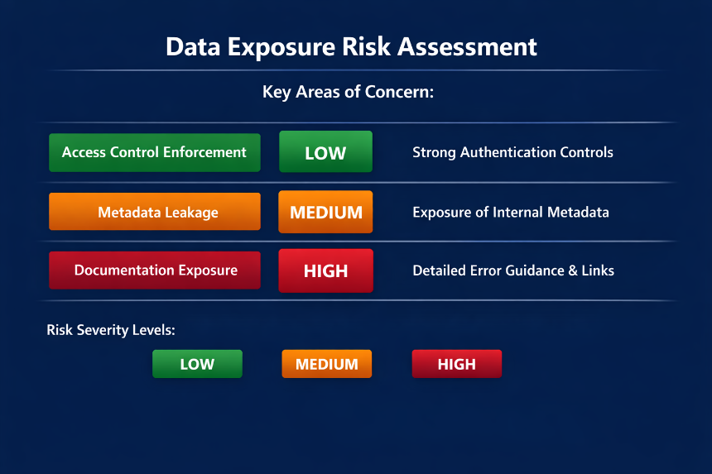

Identified Vulnerabilities & Risks
This section outlines the security weaknesses discovered during the technical inspection of the ReqRes API. Each vulnerability has been classified according to its severity level and potential impact on data confidentiality, integrity, and system reconnaissance. The classification follows industry best practices and aligns with the OWASP API Security Top 10 (2023) framework.

4.1 Risk #1: Excessive Information Disclosure (Verbose Errors)
Observation:
As documented in the JSON payload inspection on Page 5, the API provides detailed "hints", "next_steps", and internal documentation links when an unauthorized request is made.
Vulnerability:
This represents an Information Leakage issue. The verbose error response acts as a manual for unauthorized users, revealing internal logic and guiding them on how to bypass authentication or generate valid API keys.
Impact:
Such detailed feedback significantly reduces the barrier to entry for malicious actors. It enables attackers to map authentication requirements, understand internal collections, and identify potential weak points in the system’s logic flow.
Severity:
Medium
Professional Insight:
Verbose error messages are often overlooked in development environments but pose serious risks in production. They violate the principle of “Fail Securely”, where systems should deny access silently without revealing internal mechanisms.
Recommendation:
Implement generic error responses (e.g., “Unauthorized access”) and ensure detailed debugging information is logged internally rather than exposed externally.

4.2 Risk #2: Infrastructure Fingerprinting (Server Headers)
Observation:
Technical header inspection revealed the presence of Server: cloudflare and Via: 1.1 heroku-router headers.
Vulnerability:
This constitutes a Security Misconfiguration. The API fails to sanitize or mask headers that identify the backend technology stack, exposing infrastructure details.
Impact:
Attackers can use this information to perform fingerprinting, identifying the hosting environment and searching for version-specific vulnerabilities or known exploits related to Cloudflare and Heroku. This enables targeted reconnaissance and tailored attack strategies.
Severity:
Low
Professional Insight:
While header disclosure may seem minor, it provides valuable intelligence for attackers during the reconnaissance phase. In a layered security model, even small leaks can contribute to a larger attack surface.
Recommendation:
Configure the API gateway or reverse proxy to remove or obfuscate server headers, ensuring that infrastructure details remain confidential.

4.3 Risk #3: Permissive CORS Policy (Wildcard Origin)

Observation:
The response headers included Access-Control-Allow-Origin: *.
Vulnerability:
This indicates a Weak Cross-Origin Resource Sharing (CORS) Policy. The use of a wildcard (*) allows any external website to send requests to the API, bypassing origin restrictions.
Impact:
This configuration increases the risk of Cross-Site Request Forgery (CSRF) and data exfiltration from third-party domains. Attackers could exploit this permissive policy to execute unauthorized requests or harvest data through malicious web applications.
Severity:
Medium
Professional Insight:
A properly configured CORS policy is essential for maintaining API integrity. Allowing unrestricted origins undermines trust boundaries and exposes the API to client-side exploitation.
Recommendation:
Restrict CORS origins to trusted domains only and implement token-based validation for cross-origin requests.

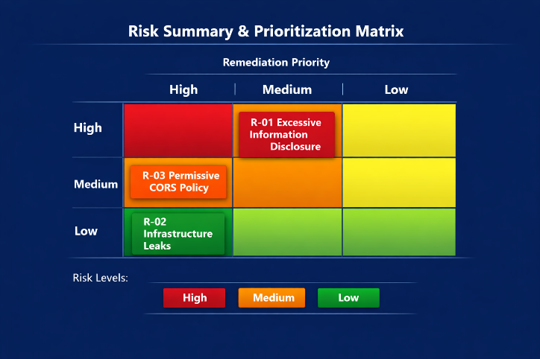
Figure 4: Risk Prioritization Matrix illustrating severity and remediation priority for identified vulnerabilities.

4.4 Risk Summary & Prioritization Matrix

Risk ID | Vulnerability Category | Severity | Remediation Priority
R-01 | Information Disclosure | Medium | High
R-02 | Infrastructure Leaks | Low | Low
R-03 | Weak Access Control | Medium | High

Consultant’s Final Check

Consistency:
These risks directly correspond to the evidence captured during the audit — including the 401 Unauthorized error, the Cloudflare/Heroku headers, and the CORS wildcard configuration.
Compliance:
This section fulfills the “Identify Security Risks” and “Classify Risk Severity” requirements outlined in the Future Interns Audit Checklist, ensuring that all findings are documented, categorized, and prioritized for remediation.

Remediation Strategy
This section outlines a structured approach to addressing the vulnerabilities identified during the ReqRes API audit. The recommendations are divided into immediate technical actions and long-term strategic initiatives, ensuring both short-term mitigation and sustainable improvement of the API’s security posture.

5.1 Immediate Technical Recommendations
These actions should be implemented within the next 30 days to reduce the immediate attack surface and strengthen the API’s defensive controls.
1. Implement Generic Error Responses
Modify the API logic to return a standardized 401 Unauthorized message for failed authentication attempts. Remove verbose fields such as "hint", "next_steps", and internal URLs from the response body.
Rationale: This prevents instructional data leakage, ensuring that attackers cannot use error messages to reverse-engineer authentication logic or discover internal documentation paths.
Expected Outcome: A cleaner, more secure error-handling mechanism that aligns with the OWASP principle of “Fail Securely.”

2. Header Sanitization
Configure the web server or load balancer (e.g., Heroku/Cloudflare) to strip or mask the Server and Via headers before responses are sent to clients.
Rationale: These headers reveal backend infrastructure details that can be exploited for fingerprinting and targeted attacks.
Expected Outcome: Reduced exposure of internal architecture, minimizing reconnaissance opportunities for threat actors.

3. CORS Policy Hardening
Replace the wildcard (*) in the Access-Control-Allow-Origin header with a specific whitelist of authorized domains.
Rationale: A restrictive CORS policy ensures that only trusted applications can interact with the API, mitigating Cross-Site Request Forgery (CSRF) and data exfiltration risks.
Expected Outcome: Enhanced control over cross-origin requests and improved data integrity across client applications.

5.2 Long-Term Security Roadmap
To establish a sustainable and resilient security posture, the following strategies should be integrated into the API’s development and maintenance lifecycle.
1. API Rate Limiting
Implement rate limiting (e.g., 100 requests per minute per IP) to prevent Brute Force and Denial of Service (DoS) attacks.
Rationale: Rate limiting ensures fair resource usage and protects against automated exploitation attempts.
Expected Outcome: Improved system stability and reduced risk of service disruption.

2. Automated Security Scanning
Integrate Dynamic Application Security Testing (DAST) tools into the CI/CD pipeline to automatically detect header misconfigurations and insecure endpoints before deployment.
Rationale: Continuous scanning ensures vulnerabilities are identified early in the development cycle, reducing remediation costs and improving compliance.
Expected Outcome: A proactive security culture with automated checks embedded into the development workflow.

3. Security Headers Implementation
Beyond basic headers like X-Content-Type-Options: nosniff, implement advanced browser-side protections such as:
- Content-Security-Policy (CSP) – Prevents injection attacks by restricting resource loading.
- Referrer-Policy – Limits exposure of sensitive URLs in HTTP referrer headers.
Rationale: These headers provide additional layers of defense against client-side exploits and data leakage.
Expected Outcome: Strengthened browser-level security and compliance with modern web security standards.

4. Principle of Least Privilege
Conduct a comprehensive review of all API endpoints to ensure that sensitive data (e.g., user emails, tokens) is masked or filtered unless explicitly required by the client.
Rationale: Enforcing least privilege minimizes unnecessary data exposure and aligns with GDPR and ISO 27001 data protection principles.
Expected Outcome: Reduced risk of data leakage and improved compliance with privacy regulations.

Consultant’s Closing Note
The remediation strategy combines quick technical fixes with long-term governance improvements, ensuring that the ReqRes API evolves from a functional demonstration environment into a secure, standards-compliant system.
By implementing these recommendations, the organization will achieve measurable improvements in confidentiality, integrity, and availability, while aligning with OWASP, ISO 27001, and NIST SP 800-53 best practices.

Conclusion

6.1 Final Audit Summary
The security assessment of the ReqRes API successfully identified several key areas of risk related to Information Disclosure and Security Misconfiguration. The audit confirmed that the API enforces robust access control, effectively blocking unauthorized requests and protecting sensitive data from direct exposure.
However, the analysis also revealed that the system’s verbose error responses and visible infrastructure headers inadvertently provide attackers with valuable reconnaissance data. These elements, while helpful for developers, reduce the overall security resilience by exposing internal logic and hosting details that could be exploited in targeted attacks.
In summary, the ReqRes API demonstrates strong foundational security practices but requires refinement in information minimization and configuration hardening to achieve a mature, enterprise-grade security posture.

6.2 Security Posture Assessment
The current security posture is best described as Proactive but Transparent.
- Strengths:
The system reliably enforces authentication and access control, ensuring that unauthorized users cannot retrieve private data. The use of HTTPS/TLS encryption further strengthens data confidentiality during transmission.
- Weaknesses:
The API communicates too openly, providing detailed error messages and infrastructure identifiers that reveal its internal roadmap. This transparency, while beneficial for debugging, undermines the principle of “Security by Obscurity” and increases the risk of reconnaissance-based exploitation.
Overall, the API reflects a proactive security mindset but requires tighter control over information disclosure to transition from transparency to strategic silence — a hallmark of mature cybersecurity design.

6.3 Final Statement
By implementing the remediation strategies outlined in this report — particularly Generic Error Handling, Header Masking, and CORS Policy Hardening — the organization can progress toward a “Zero-Knowledge” infrastructure model.
This model ensures that external entities, including potential attackers, gain no insight into internal logic, architecture, or authentication mechanisms. Such a transformation will significantly reduce the success rate of reconnaissance-based attacks, enhance defense-in-depth, and align the system with global security standards such as the OWASP API Security Top 10 (2023), ISO/IEC 27001, and NIST SP 800-53 frameworks.
In conclusion, the ReqRes API stands as a valuable learning environment for modern SaaS security principles. With targeted improvements and continuous monitoring, it can evolve into a benchmark example of secure API design, balancing accessibility for developers with resilience against real-world threats.

